COMPUTER NETWORKS

BCSE308P

LAB WORK - 4

NAME: Adhithya Kumar Tummala

REG NO: 24BCE1588

NS-3 INSTALLATION (Version 3.39) in ubuntu:

STEP-1 : Installing ns3.39 version from official ns3 website
Link : https://www.nsnam.org/releases/ns-allinone-3.39.tar.bz2

STEP-2 : Extract the file and save in home

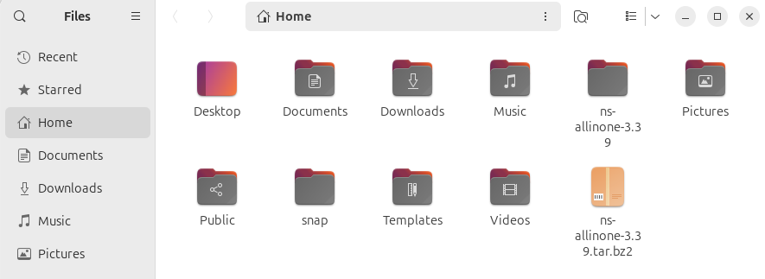
STEP-3 : Navigating to : ns-3allinone-3.39 -> ns-3.39 and then openeing terminal
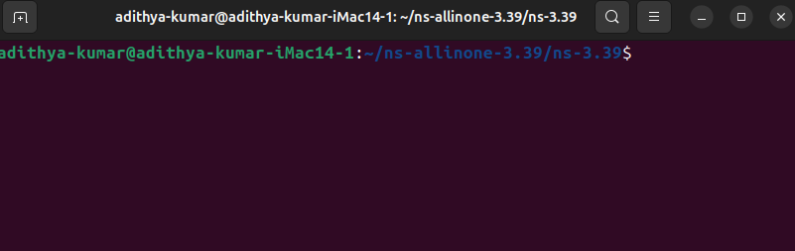

STEP-4 : Enter command ./ns-3 configure
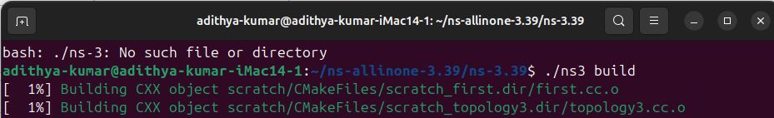
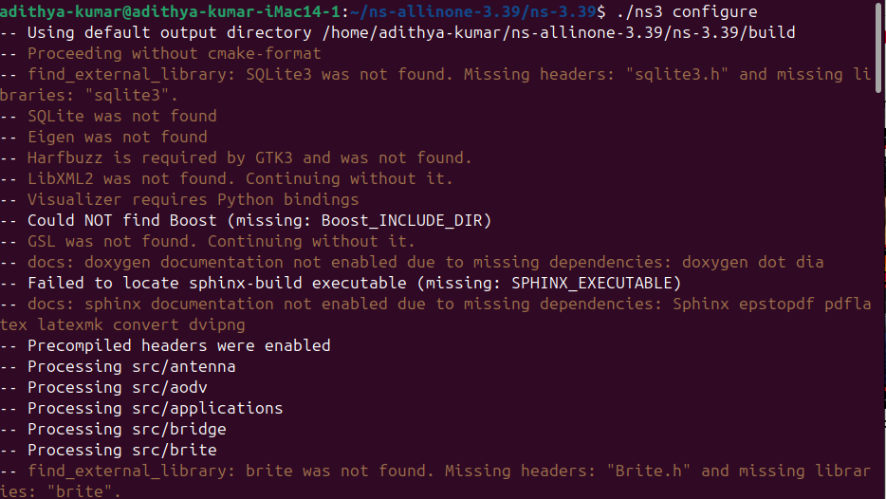
STEP-5 : Enter command ./ns-3 build
Now ns-3 has been installed successfully
Proof:
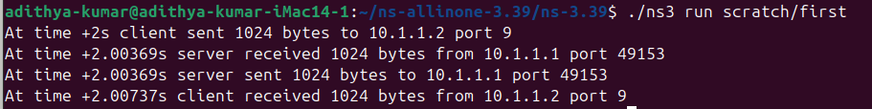

Creating 5 topologies using ns3 and displaying :

1) Star topology:

Creating a file named star.cc and saving the c code in tht
#include "ns3/core-module.h"
#include "ns3/network-module.h"
#include "ns3/internet-module.h"
#include "ns3/point-to-point-module.h"
#include "ns3/point-to-point-layout-module.h"
#include "ns3/netanim-module.h"
#include "ns3/mobility-module.h"

using namespace ns3;

int main (int argc, char *argv[]) {
// 1. Create the Star Helper (1 Hub + 19 Spokes = 20 Nodes)
PointToPointHelper p2p;
p2p.SetDeviceAttribute ("DataRate", StringValue ("5Mbps"));
p2p.SetChannelAttribute ("Delay", StringValue ("2ms"));

PointToPointStarHelper star (19, p2p);

// 2. Install Internet Stack
InternetStackHelper internet;
star.InstallStack (internet);

// 3. Assign IP Addresses
Ipv4AddressHelper address;
address.SetBase ("10.1.1.0", "255.255.255.0");
star.AssignIpv4Addresses (address);

// 4. FIX: Install Mobility Model Loop
MobilityHelper mobility;
mobility.SetMobilityModel ("ns3::ConstantPositionMobilityModel");

// Install on Hub
mobility.Install (star.GetHub ());

// Install on Spokes (Looping manually because GetSpokeNodes() failed)
for (uint32_t i = 0; i < 19; ++i)
{
mobility.Install (star.GetSpokeNode (i));
}

// 5. Setup Animation
AnimationInterface anim ("star.xml");
star.BoundingBox (100, 100, 400, 400);

Simulator::Run ();
Simulator::Destroy ();
return 0;
}

Executing:
After executing the star c code it will create a file named star.xml

Output:
Displaying animation:
Displaying tht file star.xml using netanim:

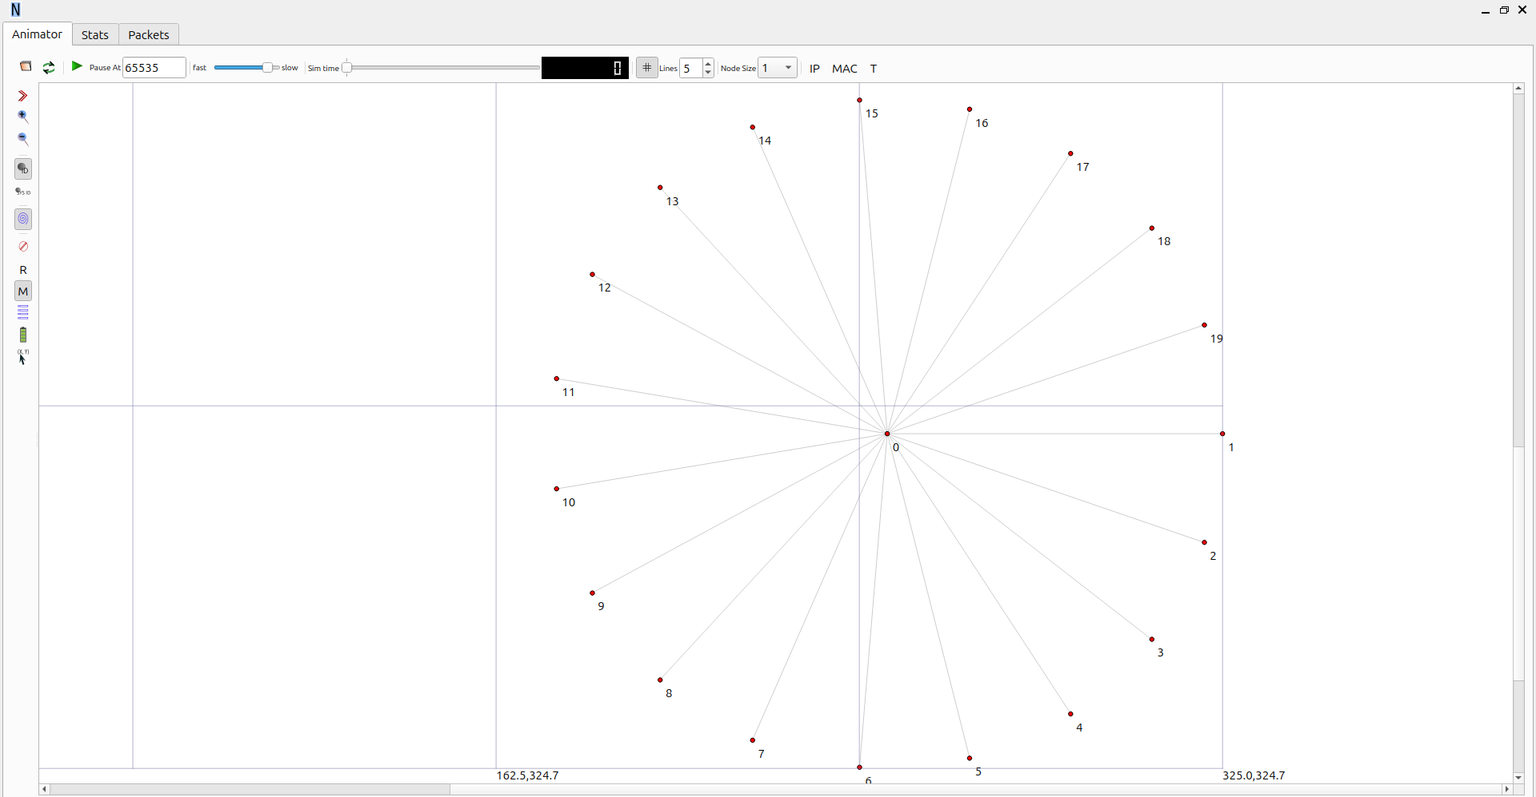

2) Hybrid topology:

Creating a file named hybrid.cc and saving the c code in tht

#include "ns3/core-module.h"
#include "ns3/network-module.h"
#include "ns3/internet-module.h"
#include "ns3/point-to-point-module.h"
#include "ns3/csma-module.h"
#include "ns3/netanim-module.h"
#include <cmath>

using namespace ns3;

int main (int argc, char *argv[])
{
// --- 1. NODE CREATION (Total 23) ---
// Left: Star (1 Hub + 11 Spokes = 12 Nodes)
NodeContainer starNodes;
starNodes.Create (12);
Ptr<Node> starHub = starNodes.Get (0);

// Right: Bus (11 Nodes)
NodeContainer busNodes;
busNodes.Create (11);

// --- 2. CONFIGURE HELPERS ---
PointToPointHelper p2p;
p2p.SetDeviceAttribute ("DataRate", StringValue ("5Mbps"));
p2p.SetChannelAttribute ("Delay", StringValue ("2ms"));

CsmaHelper csma;
csma.SetChannelAttribute ("DataRate", StringValue ("100Mbps"));
csma.SetChannelAttribute ("Delay", StringValue ("6560ns"));

InternetStackHelper stack;
stack.Install (starNodes);
stack.Install (busNodes);

Ipv4AddressHelper address;

// --- 3. BUILD STAR (Left Side) ---
// Connect Hub to all Spokes
for (uint32_t i = 1; i < 12; ++i) {
NetDeviceContainer link = p2p.Install (starHub, starNodes.Get (i));
std::ostringstream subnet;
subnet << "10.1." << i << ".0";
address.SetBase (subnet.str ().c_str (), "255.255.255.0");
address.Assign (link);
}

// --- 4. BUILD BUS (Right Side) ---
// Connect all Bus nodes to CSMA
NetDeviceContainer busDevices = csma.Install (busNodes);
address.SetBase ("10.2.1.0", "255.255.255.0");
address.Assign (busDevices);

// --- 5. BRIDGE THEM (Center) ---
// Connect Star Hub -> Middle Bus Node (Node 5)
NetDeviceContainer bridge = p2p.Install (starHub, busNodes.Get (5));
address.SetBase ("10.3.1.0", "255.255.255.0");
address.Assign (bridge);

// --- 6. VISUALIZATION (Non-Intersecting Layout) ---
AnimationInterface anim ("hybrid_star_bus.xml");

// A. STAR LAYOUT (Left Zone: X=30)
// Drawn as a Circle
anim.SetConstantPosition (starHub, 30.0, 50.0);
for (uint32_t i = 1; i < 12; ++i) {
double angle = 2 * 3.14159 * i / 11;
anim.SetConstantPosition (starNodes.Get (i),
30.0 + 20.0 * cos (angle),
50.0 + 20.0 * sin (angle));
}

// B. BUS LAYOUT (Right Zone: X=120)
// Drawn as a VERTICAL Line (Top to Bottom)
// This looks completely different from the Star circle.
for (uint32_t i = 0; i < 11; ++i) {
anim.SetConstantPosition (busNodes.Get (i),
120.0, // Fixed X (Right side)
20.0 + (i * 6.0) // Varying Y (Vertical)
);
}

Simulator::Run ();
Simulator::Destroy ();
return 0;
}

Executing it through command “./ns3 run scratch/hybrid “ creates a file named hybrid.xml
Output:

Displaying output through netanim:
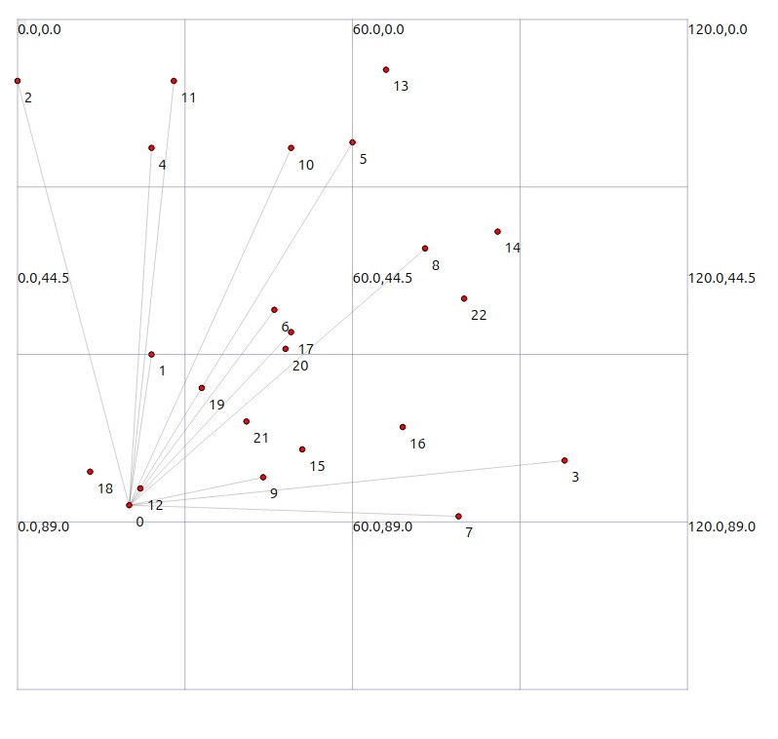

3) Ring topology:

Creating a file named ring.cc and saving the c code in tht

#include "ns3/core-module.h"
#include "ns3/network-module.h"
#include "ns3/internet-module.h"
#include "ns3/point-to-point-module.h"
#include "ns3/netanim-module.h"
#include "ns3/mobility-module.h"
using namespace ns3;
int main (int argc, char *argv[])
{
uint32_t nNodes = 20;
NodeContainer nodes;
nodes.Create (nNodes);
// 1. Create Links (Point-to-Point)
PointToPointHelper p2p;
p2p.SetDeviceAttribute ("DataRate", StringValue ("5Mbps"));
p2p.SetChannelAttribute ("Delay", StringValue ("2ms"));
InternetStackHelper internet;
internet.Install (nodes);
Ipv4AddressHelper address;
// 2. Loop to connect Ring
for (uint32_t i = 0; i < nNodes; ++i)
{
// Connect Node i to Node i+1 (wrapping around to 0 at the end)
NetDeviceContainer link = p2p.Install (nodes.Get(i), nodes.Get((i+1) % nNodes));
// Assign unique subnet to each link (10.1.1.0, 10.1.2.0, etc.)
std::ostringstream subnet;
subnet << "10.1." << (i + 1) << ".0";
address.SetBase (subnet.str ().c_str (), "255.255.255.0");
address.Assign (link);
}
// 3. FIX: Install Mobility
MobilityHelper mobility;
mobility.SetMobilityModel ("ns3::ConstantPositionMobilityModel");
mobility.Install (nodes);
// 4. Setup Animation (Circular Layout)
AnimationInterface anim ("ring.xml");
double centerX = 50.0;
double centerY = 50.0;
double radius = 30.0;
for (uint32_t i = 0; i < nNodes; ++i)
{
// Math to place dots in a circle
double theta = 2.0 * 3.14159 * i / nNodes;
double x = centerX + radius * cos (theta);
double y = centerY + radius * sin (theta);
anim.SetConstantPosition (nodes.Get (i), x, y);
}
Simulator::Run ();
Simulator::Destroy ();
return 0;
}

Executing it through command “./ns3 run scratch/ring “ creates a file named ring.xml

Output:

Displaying output through netanim:

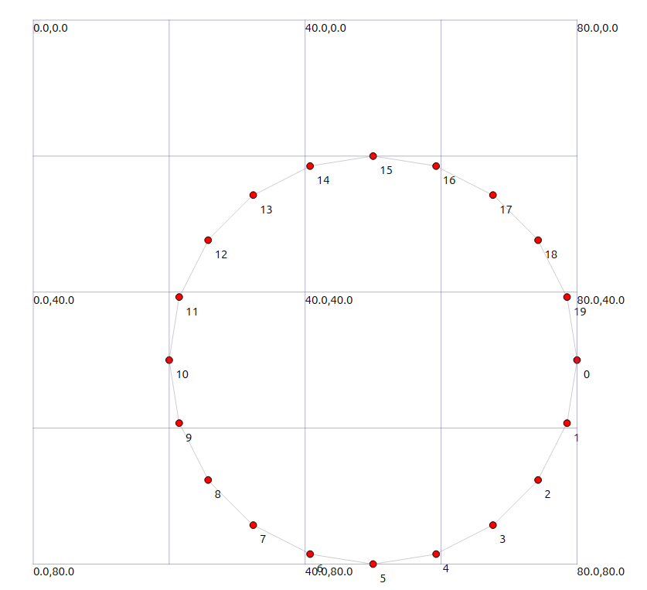

4) Grid topology:

Creating a file named grid.cc and saving the c code in tht
#include "ns3/core-module.h"
#include "ns3/network-module.h"
#include "ns3/internet-module.h"
#include "ns3/point-to-point-module.h"
#include "ns3/point-to-point-layout-module.h"
#include "ns3/netanim-module.h"
using namespace ns3;
int main (int argc, char *argv[])
{
// 1. Setup the Grid Helper (5x4)
PointToPointHelper p2p;
p2p.SetDeviceAttribute ("DataRate", StringValue ("5Mbps"));
p2p.SetChannelAttribute ("Delay", StringValue ("2ms"));
// This automatically connects the nodes in a grid pattern for you
PointToPointGridHelper grid (5, 4, p2p);
// 2. Install Internet Stack
InternetStackHelper internet;
grid.InstallStack (internet);
// 3. Assign IP Addresses
grid.AssignIpv4Addresses (Ipv4AddressHelper ("10.1.1.0", "255.255.255.0"),
Ipv4AddressHelper ("10.2.1.0", "255.255.255.0"));
// 4. Setup Animation
AnimationInterface anim ("grid.xml");
for (uint32_t r = 0; r < 5; ++r)
{
for (uint32_t c = 0; c < 4; ++c)
{
// Get the node at this specific grid spot
Ptr<Node> node = grid.GetNode (r, c);
// Set its position: X = column * spacing, Y = row * spacing
anim.SetConstantPosition (node, c * 20.0, r * 20.0);
}
}

Simulator::Run ();
Simulator::Destroy ();
return 0;
}

Executing it through command “./ns3 run scratch/grid “ creates a file named grid.xml
Output:

Displaying output through netanim:

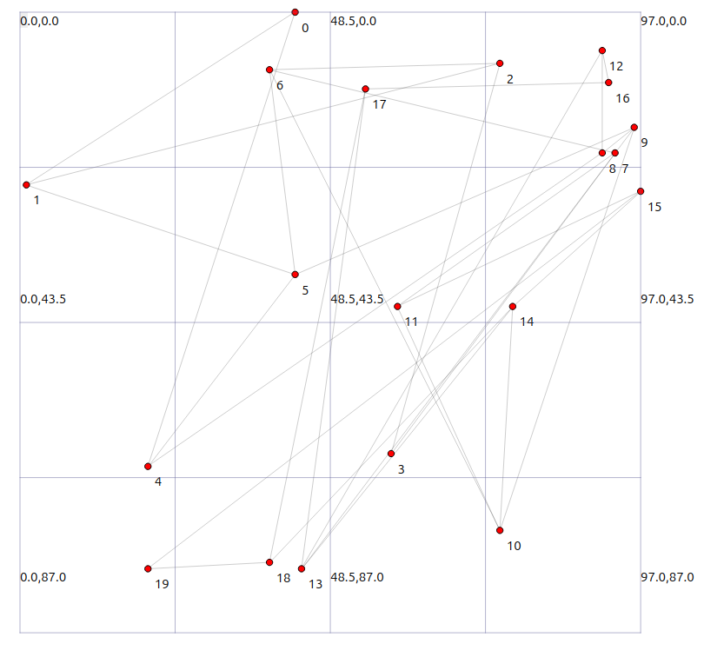

5) Mesh topology:

Creating a file named mesh.cc and saving the c code in tht

#include "ns3/core-module.h"
#include "ns3/network-module.h"
#include "ns3/internet-module.h"
#include "ns3/point-to-point-module.h"
#include "ns3/netanim-module.h"
#include <sstream> // REQUIRED for the subnet text generation
#include <cmath> // REQUIRED for sin/cos math

using namespace ns3;

int main (int argc, char *argv[])
{
// 1. Create 15 Nodes
uint32_t nNodes = 15;
NodeContainer nodes;
nodes.Create (nNodes);

// 2. Setup Link Helper
PointToPointHelper p2p;
p2p.SetDeviceAttribute ("DataRate", StringValue ("5Mbps"));
p2p.SetChannelAttribute ("Delay", StringValue ("2ms"));

// 3. Install Internet Stack
InternetStackHelper internet;
internet.Install (nodes);

// 4. Connect Every Node to Every Other Node
Ipv4AddressHelper address;
int linkCount = 1;

for (uint32_t i = 0; i < nNodes; ++i)
{
for (uint32_t j = i + 1; j < nNodes; ++j)
{
// Install link between Node i and Node j
NetDeviceContainer link = p2p.Install (nodes.Get (i), nodes.Get (j));

// Create a unique subnet for this specific link (e.g., 10.1.1.0, 10.2.1.0)
std::ostringstream subnet;
subnet << "10." << linkCount << ".1.0";

address.SetBase (subnet.str ().c_str (), "255.255.255.0");
address.Assign (link);

linkCount++;
}
}

// 5. Setup Animation
AnimationInterface anim ("mesh.xml");

// 6. Set Node Positions (Circle) so they show up in NetAnim
double centerX = 50.0;
double centerY = 50.0;
double radius = 40.0;

for (uint32_t i = 0; i < nNodes; ++i)
{
double theta = 2.0 * 3.14159 * i / nNodes;
double x = centerX + radius * cos (theta);
double y = centerY + radius * sin (theta);

anim.SetConstantPosition (nodes.Get (i), x, y);
}

// 7. Run
Simulator::Run ();
Simulator::Destroy ();
return 0;
}

Executing it through command “./ns3 run scratch/mesh “ creates a file named mesh.xml
Output:

Displaying output through netanim:

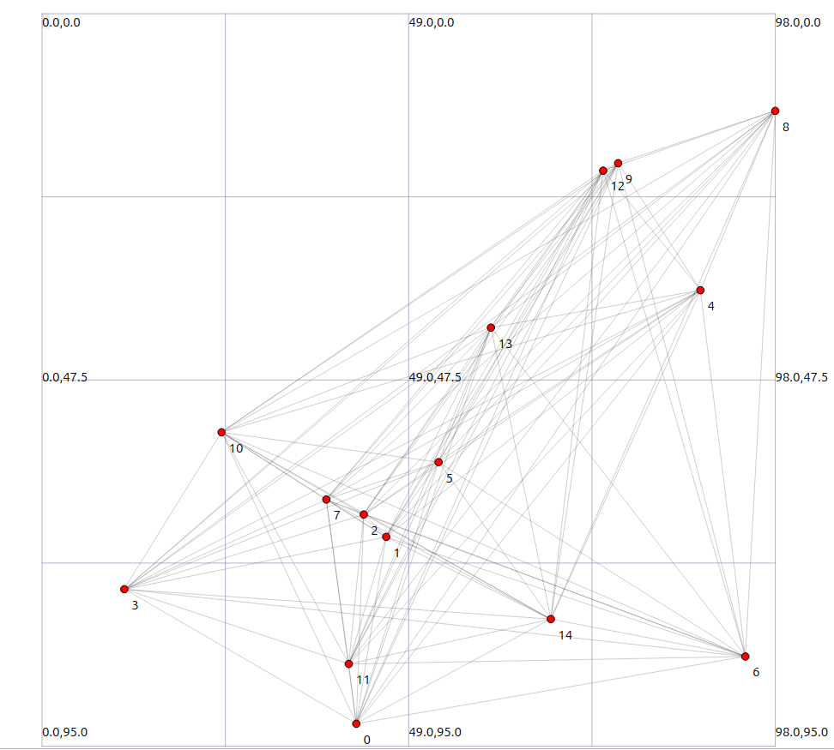

GitHub repo :
https://github.com/Adhithya-cr7/ns-3-network-topologies
Referred From:
